SAI CHANDANA THUMMA

WEEK 7 TASKS

Contents

1 Introduction 3

2 Problem/Impact/Successful Outcome 3

3 Objectives 3

4 Purpose of Document 4

5 Scope 4

6 Definitions, Acronyms, and Abbreviations 4

7 Risks 4

8 Assumptions 5

9 Issues 5

10 Dependencies 5

11 Current Process 5

12 Context Diagram 6

13 Process Overview Diagram 7

14 High-Level To Be Business Requirements 7

14.1 User Stories 8

15 Detailed Business/IT Requirements 8

15.1 Functional Requirements 8

15.2 Process Diagram 9

15.3 Non-Functional Requirements 10

16 Diagrams Overview 12

16.1 Business Process Model and Notation (BPMN) Diagram: 12

16.2 Use Case Diagram: 13

16.3 Entity-Relationship (ER) Diagram: 13

16.3.1 Properties 13

16.3.2 Relationship 14

16.3.3 ERD 16

16.3.4 Data Flow Diagram (DFD): 17

16.3.5 Wireframe or Mock-up Diagram: 18

16.3.6 Explanation: 18

16.3.7 Swimlane Diagram (Cross-Functional Flowchart): 19

16.3.8 Gantt Chart: 19

16.3.9 Stakeholder Map: 20`

16.3.10 State Diagram: 20

16.3.11 Requirement Traceability Matrix (RTM): 20

16.3.12 Gap Analysis Diagram: 21

16.3.13 Activity Diagram: 23

17 Business Impact Assessment 23

18 Costs 24

# Introduction

The Sales and Inventory Management System is going to help the company in managing its sales processes, its relationship with the customers, as well as in managing its inventory in a very effective and efficient manner. It allows salespersons to get control and manage sales teams and customers and orders together with inventory and even parts assembling. Implementation of this system is anticipated to increase efficiency of services, resultant to improved customer relations, and effective and efficient use of resources.

# Problem/Impact/Successful Outcome

|  |  |  |
| --- | --- | --- |
| The Problem | The Impact | The Successful Outcome |
| The current sales and inventory processes are manual and disconnected, leading to inefficiencies, data inaccuracies, and delays in fulfilling orders. | Inaccurate inventory tracking can result in stockouts or overstocking, affecting customer satisfaction and sales. | A successful outcome involves implementing an integrated system that automates sales and inventory processes, ensuring real-time data accuracy and faster order fulfilment. |

# Objectives

|  |  |  |  |
| --- | --- | --- | --- |
| ID | Business Objective | Business Owner | Business Importance |
| O01 | To automate the management of sales teams, customers, orders, and inventory. | Sales Department | High |
| O02 | To improve the accuracy of inventory tracking and order processing. | Inventory Management | High |
| O03 | To enhance customer relationship management by providing timely and accurate information. | Customer Service | High |

# Purpose of Document

This Business Requirements Specification (BRS) document captures the specifications for the development of Sales and Inventory Management System. It covers all of the fundamental business needs that are required in the current and new venture in a structured way to enable review and approval by other stakeholders. The document helps in planning the optimum solution to the organization’s problems and the plan this provides the basis for designing the solution that would best satisfy the company’s needs.

# Scope

|  |  |
| --- | --- |
| In Scope | Out Of Scope |
| 1. Development of a system for managing sales teams, customers, orders, and inventory. | 1. Integration with third-party e-commerce platforms. |
| 2. Implementation of a real-time inventory tracking system. | 2. Advanced analytics and reporting beyond standard operational reports. |
| 3. Creation of a dashboard for managing sales and inventory processes. | 3. Mobile application development. |

# Definitions, Acronyms, and Abbreviations

|  |  |
| --- | --- |
| Abbreviation/Acronym | Description |
| ERP | Enterprise Resource Planning |
| CRM | Customer Relationship Management |
| SKU | Stock Keeping Unit |

# Risks

|  |  |  |  |
| --- | --- | --- | --- |
| Ref | Risk | Detailed BRS Reference | Detailed Description |
| R01 | Data inaccuracies due to manual data entry. | Functional Requirements | Incorrect data entry can lead to inventory mismatches and incorrect order processing. |
| R02 | System downtime affecting sales operations. | Non-Functional Requirements | Any technical issues causing downtime could disrupt sales activities and impact revenue. |

# Assumptions

|  |  |  |
| --- | --- | --- |
| Ref | Assumption | Detailed BRS Reference |
| A01 | Salespersons will have adequate training to use the system effectively. | Functional Requirements |
| A02 | The system will be accessible via a stable internet connection. | Non-Functional Requirements |

# Issues

|  |  |  |
| --- | --- | --- |
| Ref | Issue | Detailed BRS Reference |
| I01 | Resistance to change from sales personnel. | High-Level To Be Business Requirements |

# Dependencies

|  |  |  |
| --- | --- | --- |
| Ref | Dependency | Detailed BRS Reference |
| D01 | Integration with existing ERP systems. | Functional Requirements |
| D02 | Availability of IT support for system maintenance. | Non-Functional Requirements |

# Current Process

At the moment, all Sales processes are handled manually whereby different salespersons are independently involved in handling customer relations, orders and stocks. This means that manual processing results in time wastage due to delayed order fulfilment and inconsistencies with inventory management.

# Context Diagram

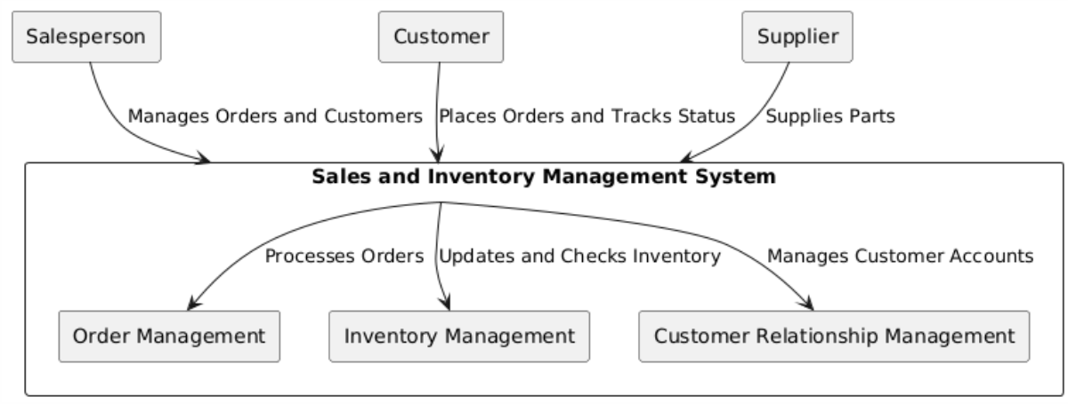

* **Salesperson** communicate with the Order Management and Customer Relationship Management subsystems of the system.
* **Customer** inputs their order and monitors the progress of his/her order through the system.
* **Supplier** delivers parts into manufacturing, where it is identified and controlled under the Inventory Control part.
* The **Order Management** and the **Inventory management** components work hand in hand to ensure that during placing of order, the status of the inventory is checked as well as updated.
* In the Sales Inventory Management System, the main components interact as follows:

# Process Overview Diagram

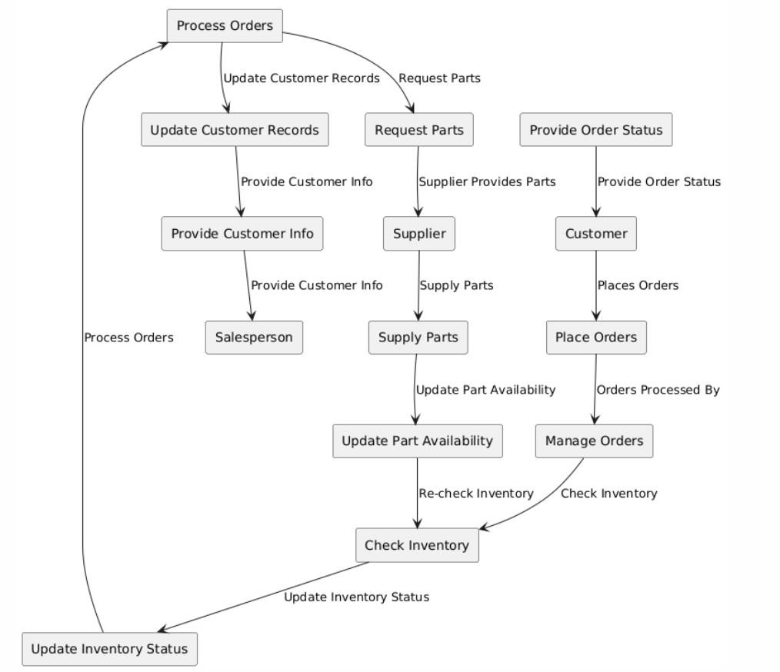

* **Roles**: Salesperson, Customer, and Supplier are represented as rectangles.
* **Activities**: Include managing orders, placing orders, checking inventory, updating status, processing orders, updating customer records, requesting parts, and supplying parts.
* **Flow**: Arrows indicate the sequence and direction of activities and interactions between roles.

# High-Level To Be Business Requirements

The To Be requirements focus on creating an integrated system that automates sales management, customer relationship management, and inventory tracking. The system will provide a unified platform for salespersons to manage their activities efficiently.

## User Stories

* **As a salesperson, I want to manage my team and customers efficiently, so that I can increase sales and improve customer satisfaction.**
* **As a customer, I want to track my order status in real-time, so that I can be informed about delivery timelines.**

# Detailed Business/IT Requirements

## Functional Requirements

|  |  |  |  |  |  |  |  |  |
| --- | --- | --- | --- | --- | --- | --- | --- | --- |
| ID | Title | Requirements Description | Type | MoSCoW Priority | Originator | Status | Delivered By | Test ID |
| FR001 | Salesperson Management | Salespersons can manage their teams and customer accounts. | Application | Must Have | Stakeholder | Proposed | Development | T001 |
| FR002 | Order Processing | Customers can place orders, and salespersons can track and fulfill them. | Application | Must Have | Stakeholder | Proposed | Development | T002 |
| FR003 | Inventory Management | The system tracks inventory in real-time, ensuring accurate stock levels. | Application | Must Have | Stakeholder | Proposed | Development | T003 |

## Process Diagram

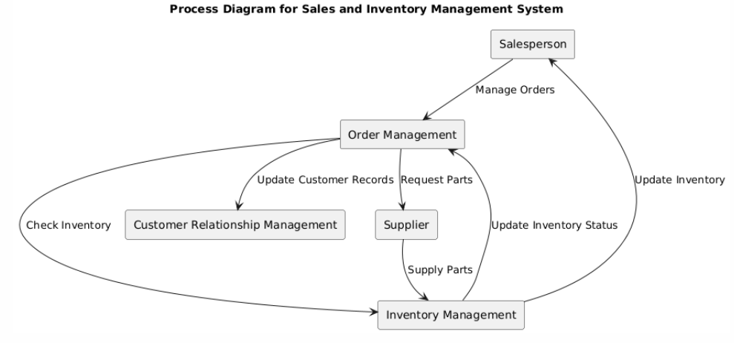

* Salesperson communicates with the Order Management to deal with orders.
* Order Management sends Customer Relation Management information of the respective customer.
* Order Management looks into the Inventory Management to determine the availability of the inventory.
* In each case, the Inventory Management sends the information on the state of inventories to the Order Management.
* The next step is initiated by Order Management; a request for parts is sent to the Supplier.
* Other parts are sent directly to the Inventory Management by the Supplier.
* Inventory Management informs the status of the inventory for the Salesperson.

## Non-Functional Requirements

|  |  |  |  |  |  |  |  |  |
| --- | --- | --- | --- | --- | --- | --- | --- | --- |
| ID | Title | Requirements Description | Type | MoSCoW Priority | Originator | Status | Delivered By | Test ID |
| NFR001 | Security | The system must have secure login and data handling processes. | Security | Must Have | Stakeholder | Proposed | Development | T004 |
| NFR002 | Performance | The system should handle up to 500 concurrent users without performance degradation. | Performance | Should Have | Stakeholder | Proposed | Development | T005 |
| NFR003 | Usability | The interface should be user-friendly and intuitive for salespersons of all levels. | Usability | Must Have | Stakeholder | Proposed | Development | T006 |

# Diagrams Overview

## Business Process Model and Notation (BPMN) Diagram:

* + **Explanation:** BPMN diagrams help visualize the flow of business processes, making it easier to identify inefficiencies and areas for improvement.

## Use Case Diagram:

## Entity-Relationship (ER) Diagram:

### Properties

|  |  |  |
| --- | --- | --- |
| Entity | Attributes | Type |
| Salesperson | SalespersonID (PK) | Primary Key |
|  | Name |  |
|  | Email |  |
|  | Phone |  |
|  | Position |  |
| Customer | CustomerID (PK) | Primary Key |
|  | Name |  |
|  | Email |  |
|  | Phone |  |
|  | Address |  |
| Order | OrderID (PK) | Primary Key |
|  | OrderDate |  |
|  | Status |  |
|  | CustomerID (FK) | Foreign Key |
|  | SalespersonID (FK) | Foreign Key |
| InventoryItem | InventoryItemID (PK) | Primary Key |
|  | Name |  |
|  | Description |  |
|  | QuantityInStock |  |
|  | SupplierID (FK) | Foreign Key |
| Part | PartID (PK) | Primary Key |
|  | Name |  |
|  | Description |  |
|  | Price |  |
| Supplier | SupplierID (PK) | Primary Key |
|  | Name |  |
|  | ContactInfo |  |
|  | Address |  |
| OrderItem | OrderItemID (PK) | Primary Key |
|  | OrderID (FK) | Foreign Key |
|  | InventoryItemID (FK) | Foreign Key |
|  | Quantity |  |
| Assembly | AssemblyID (PK) | Primary Key |
|  | InventoryItemID (FK) | Foreign Key |
|  | PartID (FK) | Foreign Key |
|  | Quantity |  |

### Relationship

|  |  |  |  |
| --- | --- | --- | --- |
| Entity 1 | Relationship | Entity 2 | Type |
| Salesperson | Manages | Order | One-to-Many |
| Order | Managed by | Salesperson | Many-to-One |
| Customer | Places | Order | One-to-Many |
| Order | Placed by | Customer | Many-to-One |
| Order | Lists | InventoryItem | Many-to-Many |
| InventoryItem | Listed on | Order | Many-to-Many |
| InventoryItem | Assembled from | Part | Many-to-Many |
| Part | Assembles | InventoryItem | Many-to-Many |
| Supplier | Supplies | Part | One-to-Many |
| Part | Supplied by | Supplier | Many-to-One |
| Order | Contains | OrderItem | One-to-Many |
| OrderItem | Part of | Order | Many-to-One |
| InventoryItem | Part of | OrderItem | One-to-Many |
| OrderItem | Represents | InventoryItem | Many-to-One |
| Assembly | Assembles | InventoryItem | Many-to-Many |
| InventoryItem | Assembled from | Assembly | Many-to-Many |
| Assembly | Contains | Part | Many-to-Many |
| Part | Assembled into | Assembly | Many-to-Many |

### ERD

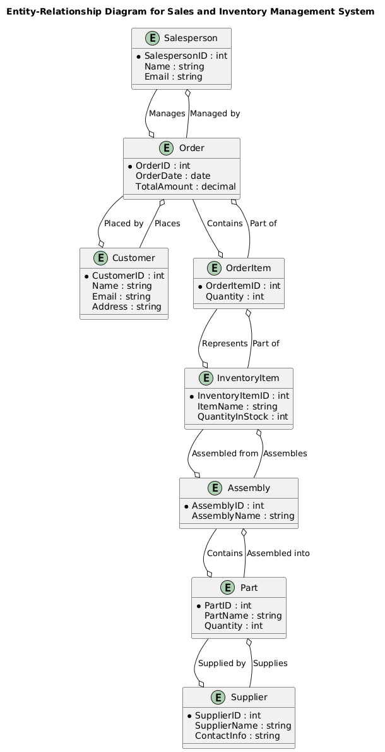

### Data Flow Diagram (DFD):

### Wireframe or Mock-up Diagram:

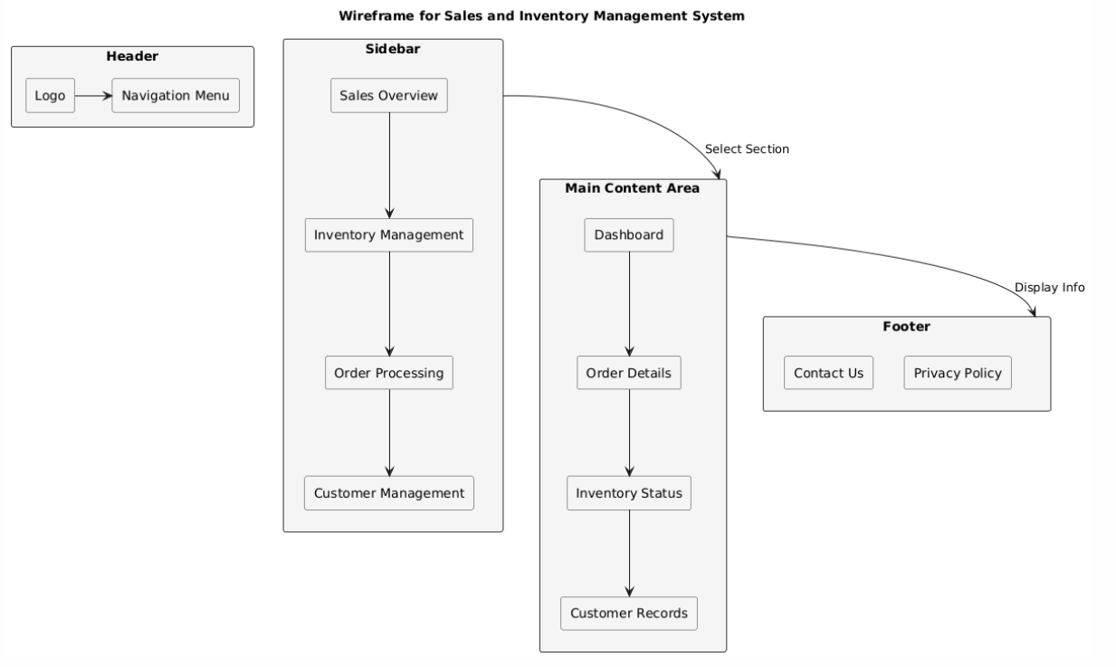

### Explanation:

* **Header**: Contains the logo and navigation menu at the top of the page.
* **Sidebar**: Positioned on the left side, includes links to different sections of the system.
* **Main Content Area**: The central part of the page where different content sections like Dashboard, Order Details, Inventory Status, and Customer Records are displayed.
* **Footer**: Located at the bottom of the page, including links for Contact Us and Privacy Policy.

### Swimlane Diagram (Cross-Functional Flowchart):

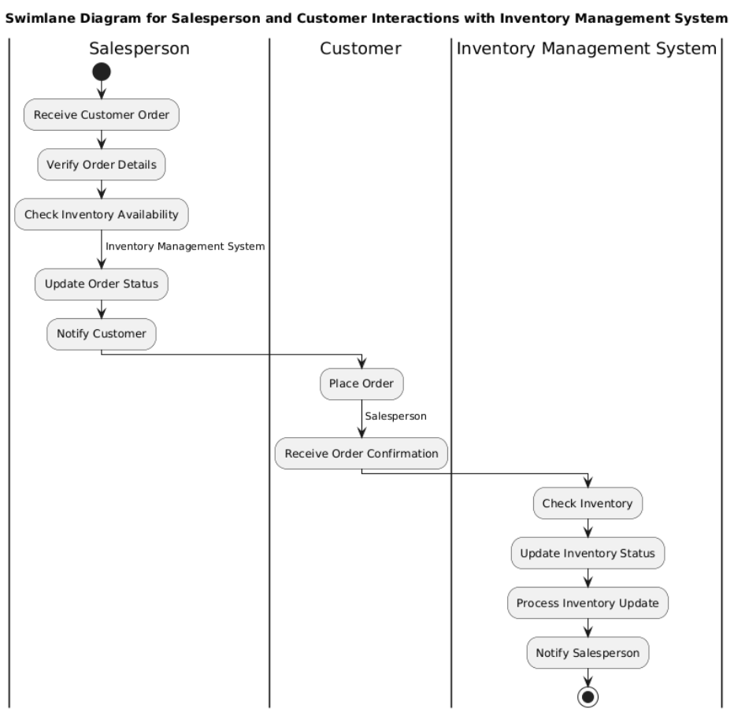

### Gantt Chart:

* + **Example:** A Gantt chart outlining the project timeline for implementing the Sales and Inventory Management System.
  + **Explanation:** Gantt charts are essential for project management, providing a timeline and dependencies for each task.

### Stakeholder Map:

### State Diagram:

**Explanation:** State diagrams illustrate the different states within a process and the transitions between them.

### Requirement Traceability Matrix (RTM):

|  |  |  |  |  |  |
| --- | --- | --- | --- | --- | --- |
| Requirement ID | Requirement Description | System Component | Use Case | Test Case | Status |
| R1 | Salesperson can manage orders and update customer info | Order Management System | Manage Orders | TC1: Validate Order Management | In Progress |
| R2 | Customer can place orders and track status | Order Management System | Place Orders, Track Status | TC2: Validate Order Placement | Not Started |
| R3 | Supplier can supply parts and update part availability | Inventory Management System | Supply Parts, Update Availability | TC3: Validate Parts Supply | Not Started |
| R4 | System processes orders and updates customer records | Order Management System | Process Orders, Update Records | TC4: Validate Order Processing | In Progress |
| R5 | System requests parts and updates part availability | Inventory Management System | Request Parts, Update Availability | TC5: Validate Parts Request | Not Started |
| R6 | System confirms orders and provides status updates | Order Management System | Confirm Orders, Provide Updates | TC6: Validate Order Confirmation | Completed |

### Gap Analysis Diagram:

|  |  |  |  |
| --- | --- | --- | --- |
| Current State | Gaps | Desired State | Actions Required |
| Manual Order Management | Lack of Automation | Automated Order Management | Implement Automation Tools |
| Disjoint Inventory Tracking | Disconnected Systems | Integrated Inventory Management | Integrate Systems |
| Basic Customer Interaction | Limited Features | Advanced Customer Interaction | Enhance Features |
| Limited Supplier Coordination | Inefficient Processes | Streamlined Supplier Coordination | Optimize Processes |

#### Explanation:

* **Current State**: Represents the current processes or systems.
* **Gaps**: Highlights the deficiencies or gaps in the current state compared to the desired state.
* **Desired State**: Represents the target or improved processes or systems.
* **Actions Required**: Lists the steps needed to bridge the gaps between the current and desired states.

### Activity Diagram:

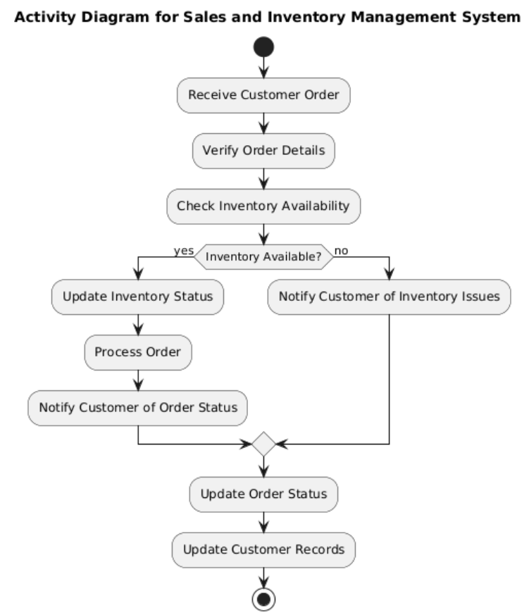

# Business Impact Assessment

When it comes to assessing the business assessment of the system; the first impact would be on its pricing which could be affected by the following factors in relation to the introduction of the Sales and Inventory Management System:

* Better stock control and rationalization of purchasing and supply chain will minimize operational costs.
* There is improved control in managing stocks that reduces the likelihood of either over or under stocking and therefore better pricing.

Nevertheless, initial expansion costs, as for software creation and employees’ training, can be higher and cause a rise in operating costs for a while. From this position, it can be suggested that over time these costs could decrease the overall life-cycle costs and increase the shares of variable costs within the final price.

# Costs

When it comes to costing of the Sales and Inventory Management System, there are several aspects that need to be taken into consideration but some of the most stand out ones are the development costs as well as the maintenance costs. Development costs refer to the cost incurred in designing and coding of the system while the maintenance costs refer to the costs involved in the constant support, update and fixing of the problems of the coded system. Training expense includes the cost incurred in providing staffs and other various personnel with information on the new system essential for the system to be implemented appropriately. Altogether, these premising investments might be significant at initial stages of implementation, but it is anticipate that the efficiency gains and concomitant decrease in operating costs would accrue in the long run.